CICOPS SCHOLARSHIPS 2020

In order to promote international co-operation, particularly with Developing Countries (re. World Bank list), the University of Pavia and EDiSU (Institute of the Right to University Studies) are offering 10 scholarships to visiting scholars for the year 2020 for a period of stay of 4 to 12 weeks at the University of Pavia.

ELIGIBILITY CRITERIA

Applicants must have at least two years of either teaching experience or activity within international organisations and institutions.
Scholarships are designed for both junior and senior members of Universities in Developing Countries or members of major research centres and international organisations or institutions with specific interest in the field of development studies.
CICOPS scholarships are reserved for research collaboration in the short term in order to encourage the mobility of researchers from developing countries. Applicants enrolled in a Doctoral or Postgraduate Course at an Italian University are not eligible to apply.
For further information please refer to the FAQ section on the website.

APPLICATIONS AND DEADLINE

In order to encourage contact between staff and students, the period of stay should take place within the following dates: January 13rd - July 20th 2020 and September 14th – December 18th 2020.

Applications must be sent no later than May 31st 2019 by filling out the online application form available on the CICOPS website:
http://www.unipv.eu/site/en/home/international-relations/cooperation-and-development/cicops-scholarships/articolo1060.html

The following documents should be uploaded to the online form:

1. Curriculum vitae ideally in European format with a list of publications
(file to be named: Surname_Name_CV)

- Invitation letter from the professor or researcher with whom you intend to collaborate
(file to be named: Surname_Name_Letter)

The uploaded documents should be named as mentioned above. Applications without a correctly named curriculum vitae and invitation letter will not be taken into consideration.
Please only fill in your application form once you have received the letter of acceptance by your contact Professor at the University of Pavia. Incomplete applications will be rejected, no exceptions will be made.

EVALUATION AND SELECTION

A decision will be made by June 30th 2019 by a Committee composed of the President of CICOPS and another two members designated by the Rector.

In the issuing of the ranking, the Committee will take into account:
1) the scientific relevance of the proposed project, especially when integrated with similar projects developed by the University of Pavia;
2) the Curriculum Vitae of the candidate;
3) the fair distribution of grants between the department involved and the geographical regions of origin of the applicants.

In the case of scientific and professional value being equal, preference will be given to:
1) applicants employed by Universities/Institutions linked to the University of Pavia with a pre-existing Cooperation Agreement (See: Elenco Accordi UNIPV, link:
http://www.unipv.eu/site/home/internazionalizzazione/attivita/articolo494.html
2) applicants from lower income economies, according to the World Bank list.

The Committee reserves the right to check the validity of declarations and supporting documents asking the submission of appropriate documentary evidence in original or certified copy. False statements may lead to exclusion from the selection process and / or the award of the scholarship.

TERMS AND CONDITIONS

a) The scholarship includes travel (economy class), food and accommodation expenses, health insurance policy and a contribution of 150.00 Euro (gross) per week.
b) Selected scholars must confirm acceptance of the scholarship and its conditions within 20 days of receipt of the email communication stating their successful application, together with the exact dates of their requested stay.
c) If a candidate fails to confirm his/her acceptance, he/she loses the right to the scholarship that will be consequently awarded to the next applicant in the ranking. Changes to the planned program agreed upon the assignment of the scholarship will not be accepted.
d) Once the University of Pavia has received the declaration of acceptance of the scholarship, we will:
- send an invitation letter in support of the visa request (with prior arrangements and in special cases a contribution for visa issuing will be granted);
- book a return flight ticket (economy class);
- stipulate a health insurance policy and personal accident insurance;
- arrange accommodation at a University College for the period of stay in Pavia;
- provide a card for meals at University canteens;
- pay the contribution.
e) The hosting Department will guarantee access to all the necessary facilities for study and research activities (libraries, computer facilities, etc.).
f) The selected scholar may be requested to deliver one or more lectures on his/her field of research.
g) At the end of the study period in Pavia, scholars must provide both a report on the work completed at the host Department and copies of any articles or publications.

Personal data submitted by the applicants will be used for application and selection procedures and for solely institutional purposes, in accordance with the Italian Legislative Decree n. 196/2003 (Italian Privacy code).

INFORMATION

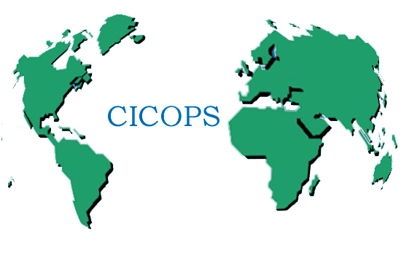
For further information please contact:

UNIVERSITY OF PAVIA - CICOPS OFFICE
Stefania Ferrari
Tel: +39 0382 984232
E-mail: cicops@unipv.it
http://www.unipv.eu/site/en/home/international-relations/cooperation-and-development.html

THE RECTOR
(Prof. Fabio Rugge)

THE CICOPS PRESIDENT
(Prof. Gian Battista Parigi)

THE EDISU PRESIDENT
(Prof. Paolo Benazzo)

(digitally signed document) Pavia, date of the protocol

For further information about the invitation letter, please refer to the FAQ section on the website.
Pre-paid tickets cannot be modified once issued.

